**Kovrigin** **CTP 103**

# Lab 8: Creating A Web Page – 50 points

##### Objectives:

* Recognize the relationship between an HTML source document and a web page
* Use HTML tags in a text editor to create a Web page

Preparation for the lab:

1. For this lab, you will use a text editor to enter HTML tags to create a web page. Both Windows and Mac have their own text editors, Notepad and TextEdit, respectively. However, there are several free, open source text editors that will work on both platforms so we are going to use one called Brackets. You can download it [here](http://brackets.io/).
2. Watch [this short video](https://youtu.be/CKlh1lwe2rY) as a general introduction to HTML.
3. Create a folder named **LastName_WebPage** where you replace LastName with YOUR last name.
4. Download the IdentityTheft.jpg image file linked in the lab dropbox and save it in the folder you just created.

##### Section I: Creating, Viewing, and Modifying a Web Page – 3 points

Hypertext Markup Language (HTML) is a standardized set of markup symbols or codes inserted in a file intended for display on a World Wide Web browser page. The markup tells the Web browser how to display a Web page’s words and images for the user. Each individual markup code is referred to as an element or tag. Some tags come in pairs that indicate when some display effect is to begin and when it is to end.

1. Creating a web page – **2 points**
   1. Open Brackets
   2. Type the following tags (Note: the Brackets program adds the line numbers and closing tags)

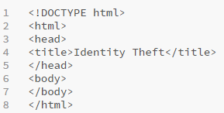

Here’s what the tags mean:

<!DOCTYPE html> DOCTYPE is not a tag, but a declaration. It describes the HTML that will be used in your page. It basically tells the web browser how to render the page.

<html>…</html> These two tags surround the entire text of an html document. It indicates to the browser that the page is html and should be rendered as html.

<head>…</head> The code between these two tags will not be displayed in the web page. This is where you put codes such as the title tag.

<title>…</title> These two tags surround the title of the page. You will see the title of the page in the URL window of your browser.

<body>…</body> These two tags surround the text of the content that is displayed on the page.

* 1. In Brackets, click on **File** – **Save As** and type **identitytheft.html** (make sure you add the “html” file extension) in the **LastName_WebPage** folder.

1. Modifying a web page – add a heading – **1 point**

HTML defines six levels of headings. A heading element implies all the font changes, paragraph breaks before and after, and any white space necessary to render the heading. The heading elements are H1, H2, H3, H4, H5, and H6 with H1 being the highest (or most important) level and H6 the least.

* 1. Add the heading **<h1> Protecting Against Identity Theft</h1>** to your document as the first line in the body of the file. Note: if your **<h1>** tag does not automatically indent, place your insertion point at the beginning of the line and press the tab key. The indentation is not necessary but it helps to view the opening and closing tags.

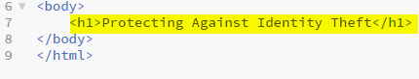

* 1. Save the document and observe the changes.

1. Viewing the web page

Brackets has a web page preview tool in the program in the upper right corner of the screen.   
It is a good idea to split your screen so you can work on your coding on one side and refresh the page as you add to the HTML code. The page will refresh every time you save the document.

Another way to view the web page is to open a browser and then navigate to the location you have the identitytheft.html document. As you change your HTML document and save it and refresh the browser page, you will see your changes.

Your preview should look like this:

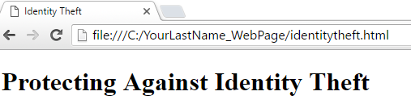

Observe that the title in the tab comes from the **<title>** tag and the “Protecting Against Identity Theft” text comes from the Heading 1 **<h1>** tag.

As you save your changes, the Brackets preview will render your changes. If it does not, click on the Refresh icon.

##### Section II – Styles – 4 points

You can alter the default appearance of an html item by adding styles to the tag.

1. Alignment – **1 point**
   1. Add the style attribute to the **<h1>** tag to center the heading on the page by adding  **style=text-align:center** to the tag. Your code will look like the example below (note that the new code is highlighted):

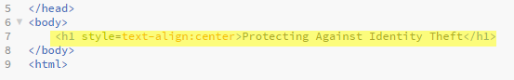

* 1. Save the file and you will see the preview refresh. Your page now looks like this:

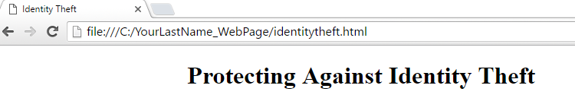

1. Text color **– 1 point**

The color attribute specifies the color for a heading text or background. You can either use the color name or the HTML hex color. For example, you can use the color name “blue” or the hex color #0000FF (we will learn more about hex colors later in the course). Click [here](http://www.w3schools.com/colors/colors_names.asp) to see a list of HTML colors.

1. Change the color of the heading to blue by adding the text **;color:blue** to the **<h1>** tag:

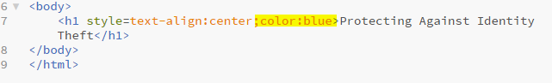

1. Save the file, refresh the page.

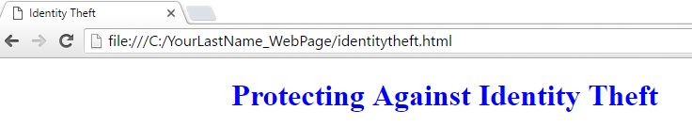

1. Background color – **1 point**
2. This requires adding a style to the body tag. You will use the color “LightSteelBlue”, which has the hex value of #B0C4DE. Add **style=background-color:LightSteelBlue** to the <body> tag

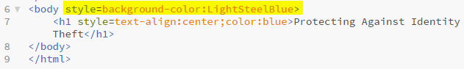

1. Save the file and refresh the page.

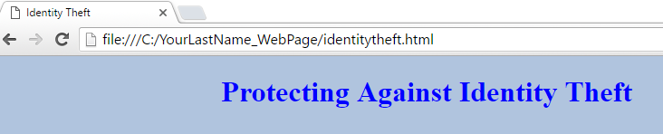

1. Horizontal line – **1 point**
2. A **horizontal line** or horizontal rule visually separates the sections within the page. The tag for a horizontal line is **<hr>**. It is placed inside the <body> tag wherever you want to place the line. Enter the tag after the **<h1>** tag, then save your changes to see the result.

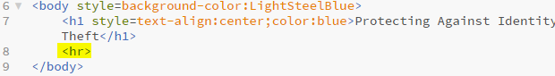

1. You can add attributes to the <hr> tag. We will add a color and size attributes. Add the following text to the tag: **style=background-color:white size=5px**

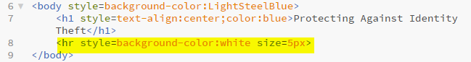

1. Save the file and refresh the page to see the impact.

##### Section III – More Formatting Tags – 4 points

* The **<div>** tag (short for division) divides the content into individual sections. Each section can then have its own formatting. We can format the **<div**> the same way that we format the **<body>** of the html page. Any style that is applied to the **<div>** applies to all elements in the **<div>.**
* **Font-family** lets you select a font. The syntax is **style=”font-family:[font name]”**
* Ordered and unordered lists help organize information on the page. The tag for an ordered (numbered) list is **<ol>**. The tag for an unordered (bulleted) list is **<ul>**. You use the **<li>** to define a list item.

1. You will use the **<div>** tag to apply a different font to section of the page. You will have two **<h2>** headings with an ordered (numbered list) on one and an unordered (bulleted) list on the other. After the horizontal rule **<hr>** tag add the following for the ordered list (Note: the indenting is not required in HTML but it helps to view the markup) **2 points**:

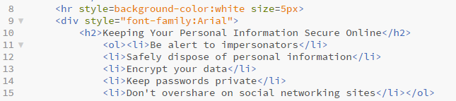

* 1. Save the file and refresh the page.

1. Next you will create an unordered (bulleted) list. **2 points**

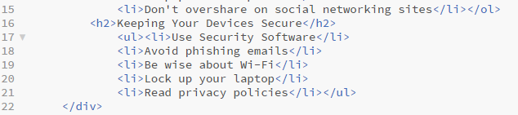

1. Save and refresh the page.

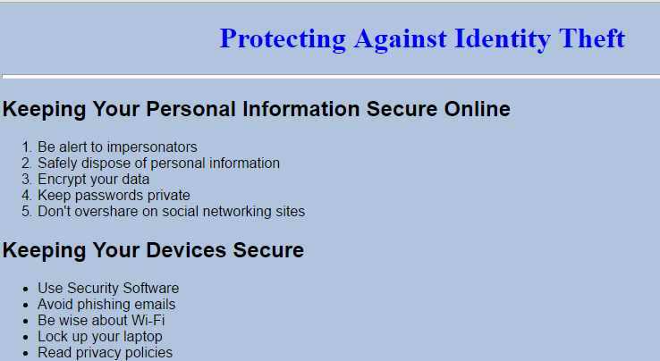

##### Section IV – Links – 2 points

To create a link, you will need an <a href> tag with the URL of the website (in quotation marks) and the text that represents the link itself, in this case, Federal Trade Commission.

1. Create a link to source for the information provided in this web page
   1. Add the following code after the closing **</div>** tag (notice that there is also an opening and closing paragraph tag.) **2 points**

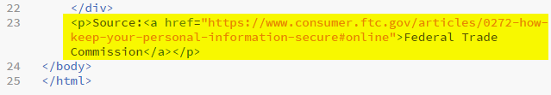

* 1. Save and view the changes.

##### Section V – Tables – 7 points

Listed below are the basic tags related to HTML tables:

|  |  |
| --- | --- |
| Tag | Description |
| <table> | Defines an HTML table |
| <th> | Defines a header cell in a table – the text is bold and centered |
| <tr> | Defines a row in a table |
| <td> | Defines a cell in a table |

1. Since we want to control the formatting for the entire table, we will open with a **<div>** tag and center-align the title of the table and the table itself with the **align** attribute.
2. Next we will add an **<h3>** heading – **Report Crimes or Suspicious Activity.**
3. Add the **<table>** tag with a border attribute of 2. The border attribute adds borders to the table
4. The first row **<tr>** of the table will be the header row so we will use **<th>** to define the element. This will center and bold the text in the cell. Note: the indentation of the tags is not necessary, but it is helpful to visualize the elements of the table to make sure you have the closing tags.

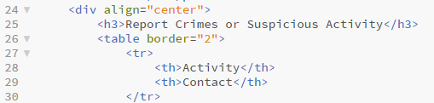

1. For each of the three rows, use a **<tr>** tag and then define the contents of each cell in the row with a **<td>** tag. Note again: do not worry if your text word-wraps for your <td> tag – this just depends on the size of your window and does not impact the layout of the page.

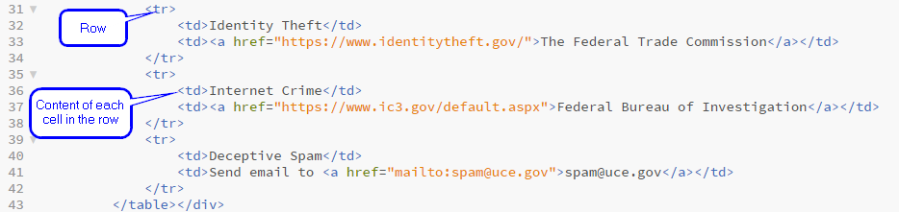

1. Add the closing </table> and </div> tags and save the document and refresh your page.

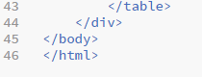

##### Section VI – Images – 5 points

The **<img src>** tag allows an image to be inserted in the html page. It stands for image source.

1. Make sure you have already downloaded the IdentityTheft.jpg image file and saved it in your **LastName_WebPage** folder.
2. We have a blank area on our page so this is where we want to insert our image. Go back to your identitytheft.html document and place your insertion point at the end of line 10, the <h2> heading “Keeping Your Personal Information Secure Online” and hit Enter.
3. On line 11 you will enter the following <img src> tag. Notice that you will add height and width attributes and the “align” attribute so the image will display on the right of the screen.



1. Save and then view the changes. Your page should look like this:

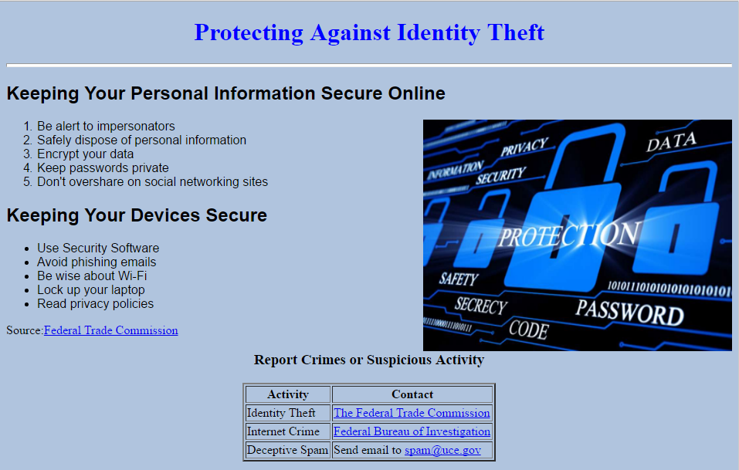

1. Observe how close the **<h3>** text “Report Crimes or Suspicious Activity” is to the image. The HTML element line break <**br**> produces a line break in text (carriage-return). Place your insertion point before that <h3> tag and hit Enter. Move the insertion point to the blank line and type <br>. This tag does not have a closing tag.
2. Save and refresh you page to view the changes.
3. Well done!! You have created a web page!

##### Section VII – Customized Web Page – 25 points

Now that you have the skills to create a web page, you will now create your own web page on the topic of your choice with the following requirements:

* Use Brackets as your text editor.
* Do not include CSS, scripts or any other add-ins.
* Include the following (**20 points**):
  + Level 1, Level 2, and Level 3 Headings – 2 points
  + Vary text color – 1 point
  + Text aligned to center – 1 point
  + Horizontal rule – 2 points
  + Background color – 1 point
  + Image (Be sure to add the image file in your Web Page folder so that is visible) – 3 points
  + At least two links (make sure you test your links to make sure they work) – 4 points
  + Table (at least 2 by 2) – 2 points
  + Ordered List (at least 3 items) – 2 points
  + Unordered List (at least 3 items) – 2 points
* Layout and creativity – if you use the exact same layout as the Identity Theft webpage, you will not earn any points for creativity. (**5 points**)
  + Create a layout that is pleasant and easy to view
  + More points earned if you create your own layout and not use the same layout as the Identity Theft page.
* Save your web page as **LastName_Custom.html** inside the **LastName_WebPage** folder.

##### Submission Instructions

1. Zip* your **LastName_WebPage** folder and submit to the dropbox in Canvas. You should have the following files in the folder:
   * identitytheft.html
   * IdentityTheft.jpg
   * LastName_Custom.html
   * The image you used for your custom page

*If you do not know how to zip a folder, click on the appropriate link below to view an instructional video:

[Windows](https://youtu.be/xuaM8Ow8zfc)

[Mac OS](https://youtu.be/k9XnfXvFNOs)